2nd June 2020
Ms Cassidy’s Music Activity
Musycling
What happens when you mix fun and lively music with recycling? You get… musycling!
This is a fun form of recycling that involves craft, science and, above all, music! With musycling you turn rubbish and unwanted items into fantastic musical instruments that can be played again and again.
You can explore sound and compose your own tunes and songs with the instruments you create. On the accompanying sheets you will find some ideas of musycle instruments you can make with rubbish from around your home, such as boxes, tin cans and plastic bottles. These instructions can also be used as inspiration to create your own musycle instruments. Once completed, you can have hours of fun creating you own tunes and songs. You may even wish to plan a musycle orchestra in which you can showcase your songs to friends and family!

Instructions
1. Firstly, think about the type of instrument you’d like to make. Will it be a string instrument? A shaker? A drum? A wind instrument?
2. Choose your materials – look for things that you think will make an interesting sound when you bang or shake them. What materials would be good to make the type of instrument you want?
3. Finally, once you have made and decorated your instruments, use them to create your own musycle song or rubbish rap. It could be a song that explains to people how to recycle or why recycling is good for the environment.

You can email your teacher a picture of your instrument or a video of you playing it!

Have fun!
Ms. Cassidy

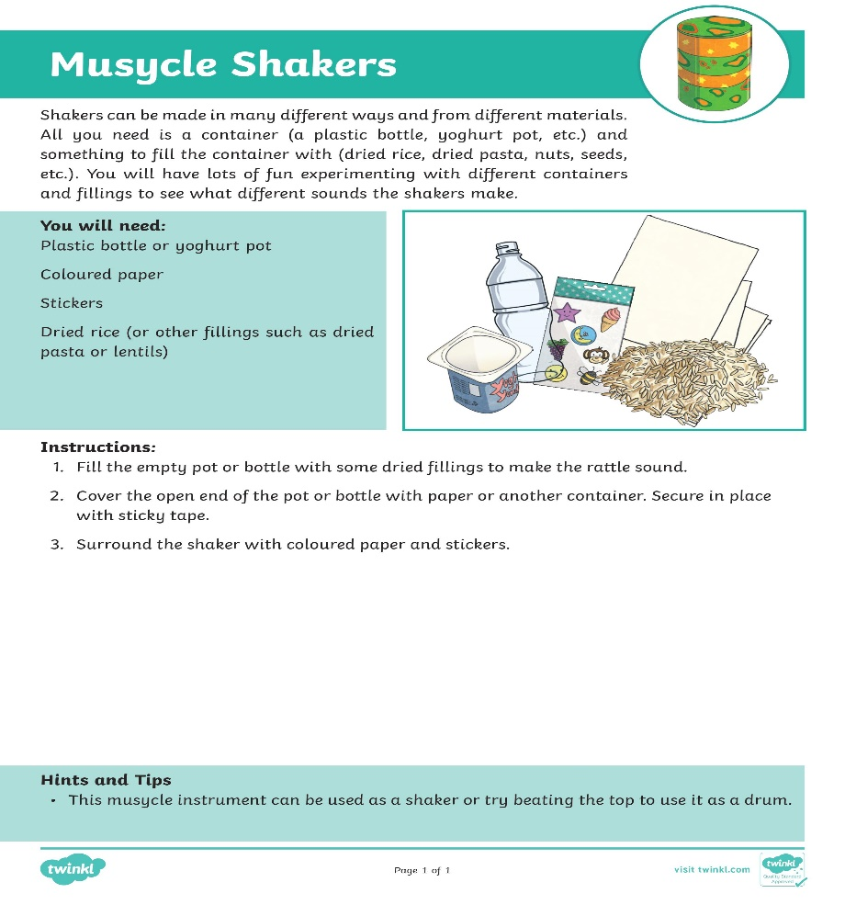
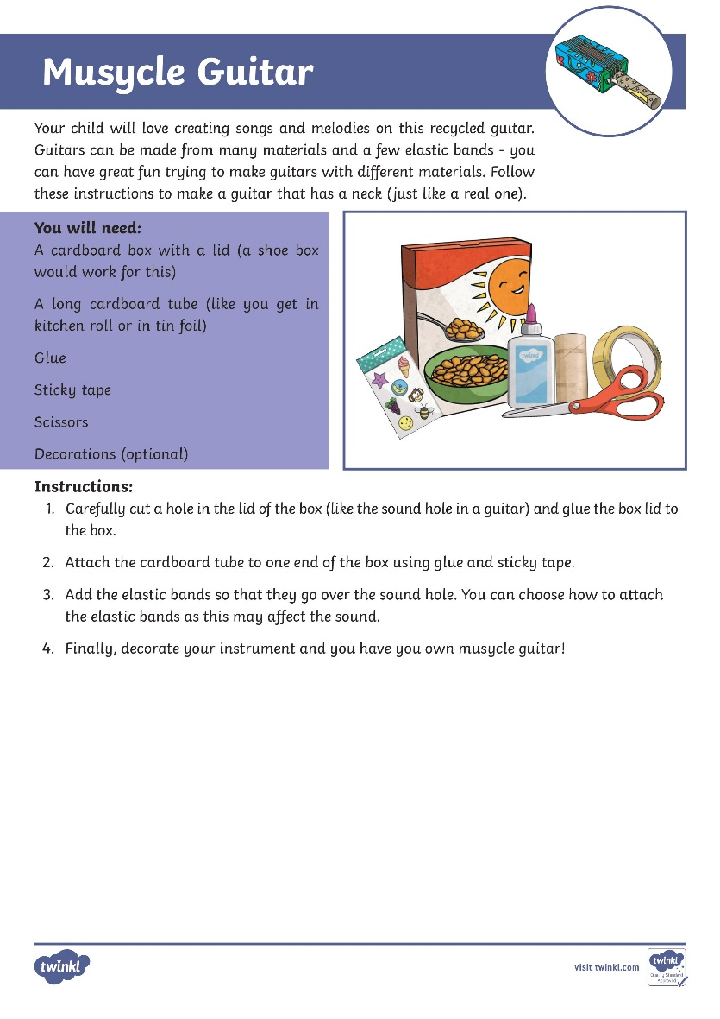

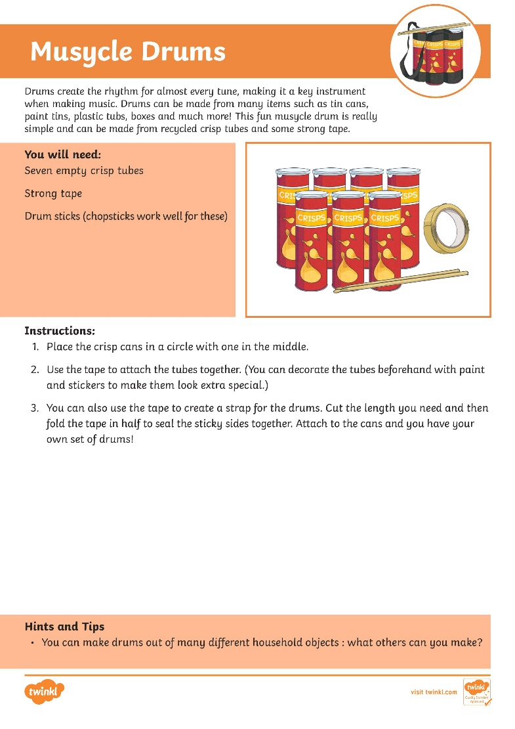
3rd June 2020
Ms Farrell-McCabe’s Science Activity

A day in the life of an Astronaut in Space.

Watch the following videos of what it is like to be an astronaut on the International Space Station (ISS).
https://www.youtube.com/watch?v=SOCixRhRGDw (Take a tour of the space station - SciShow kids)
and
https://www.youtube.com/watch?v=tBVUTFPate0 (Station Tour: Harmony, Tranquility, Unity – NASA Johnson)

Life in space is definitely very different to life on Earth. Would you like to be an astronaut? Why/why not?
Imagine you were an astronaut working on the ISS, draw a picture/ write a paragraph about a day you spent on the ISS. Think about what you ate, where did you sleep, how did you exercise, what kind of work did you do, how did you wash your hair etc?
OR
Design a poster recruiting astronauts to work on the ISS. Give them all the important information they will need to work on the space station i.e. where will they sleep, how will they exercise, what will they eat, what will they do everyday etc.
--------------------------------------------------------------------------------------------
4th June 2020
Ms Behan’s History Activity
Hi girls!
Today’s activity is a History activity! You’ll be going on a virtual tour of the British Museum in London, one of the oldest public museums in the world! Click the link below!

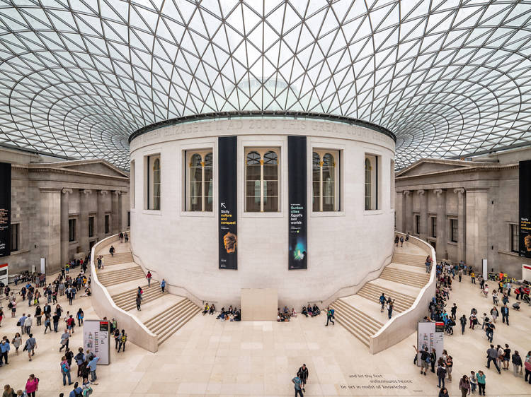
https://britishmuseum.withgoogle.com/

They have an absolutely incredible collection of different artefacts from all over the world.
Using the interactive timeline, you can look at artefacts starting from the present day (2000AD) going all the way back to 5000BC! That’s 7,000 years ago! It plays a little song as you click on different artefacts!

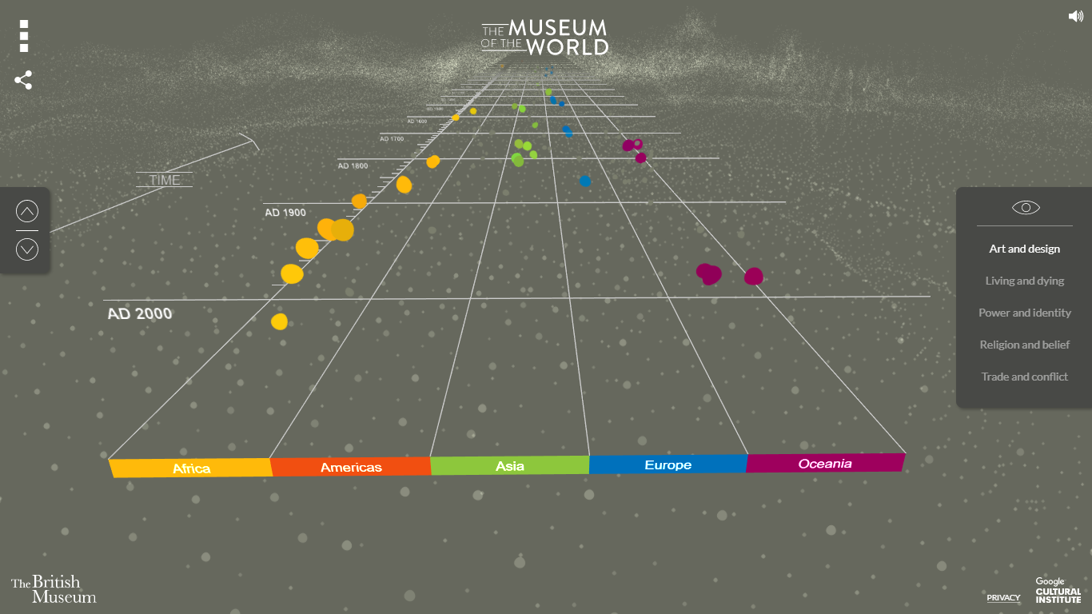
There are artefacts from Africa, the Americas, Asia, Europe and Oceania.
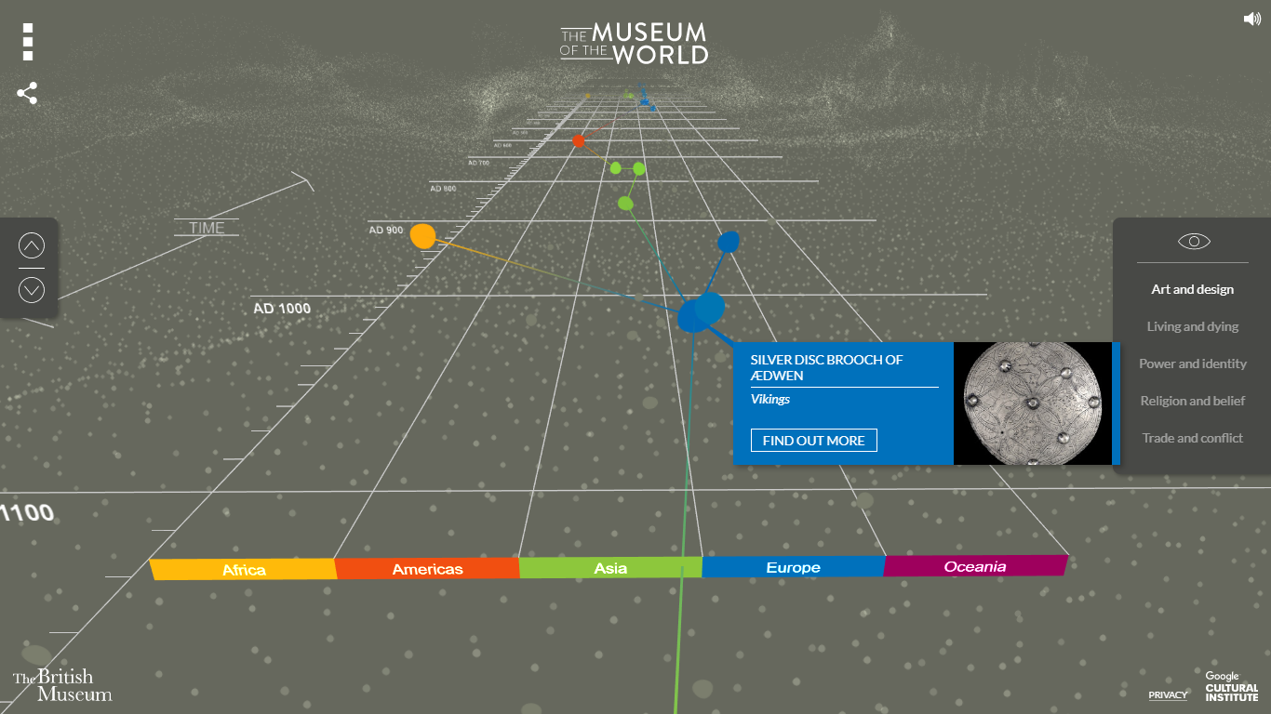
Use the arrows on the left side to move through time! Click on the dot you’d like to explore.

You can then see the name of the artefact and what historical time period it relates to! I chose the Viking Silver Brooch of Aedwen.
Click on “find out more” and you’ll see this page.

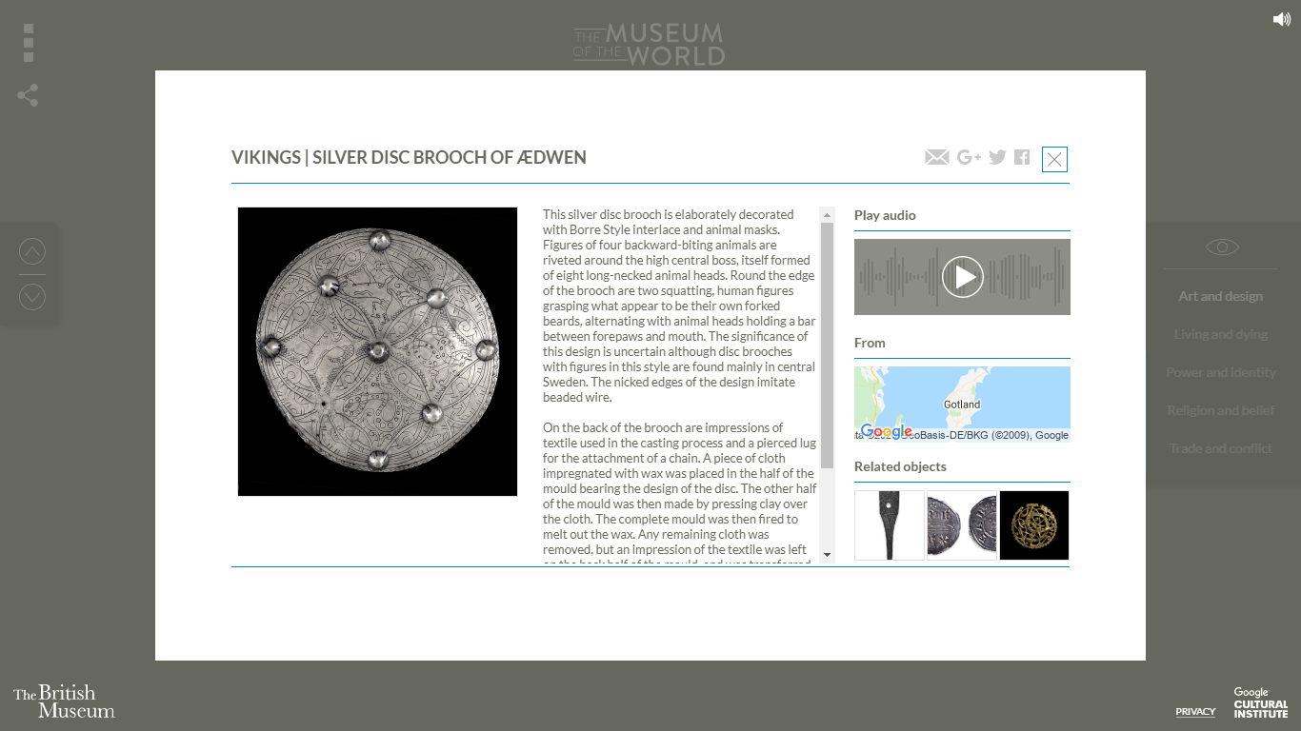
You can read the information on the artefact here. You can also listen to a historian talk about the artefact by pressing the play button the right. You can see a map of where the artefact is from and some related artefacts!

Your Challenge:
- Pick 2 of your favourite artefacts.
- Write their names, time period and place.
- Write 1 interesting fact or bit of information about each artefact.
- Draw a simple picture of each artefact.
- Send a picture of your work to your teacher!

Here’s my example:
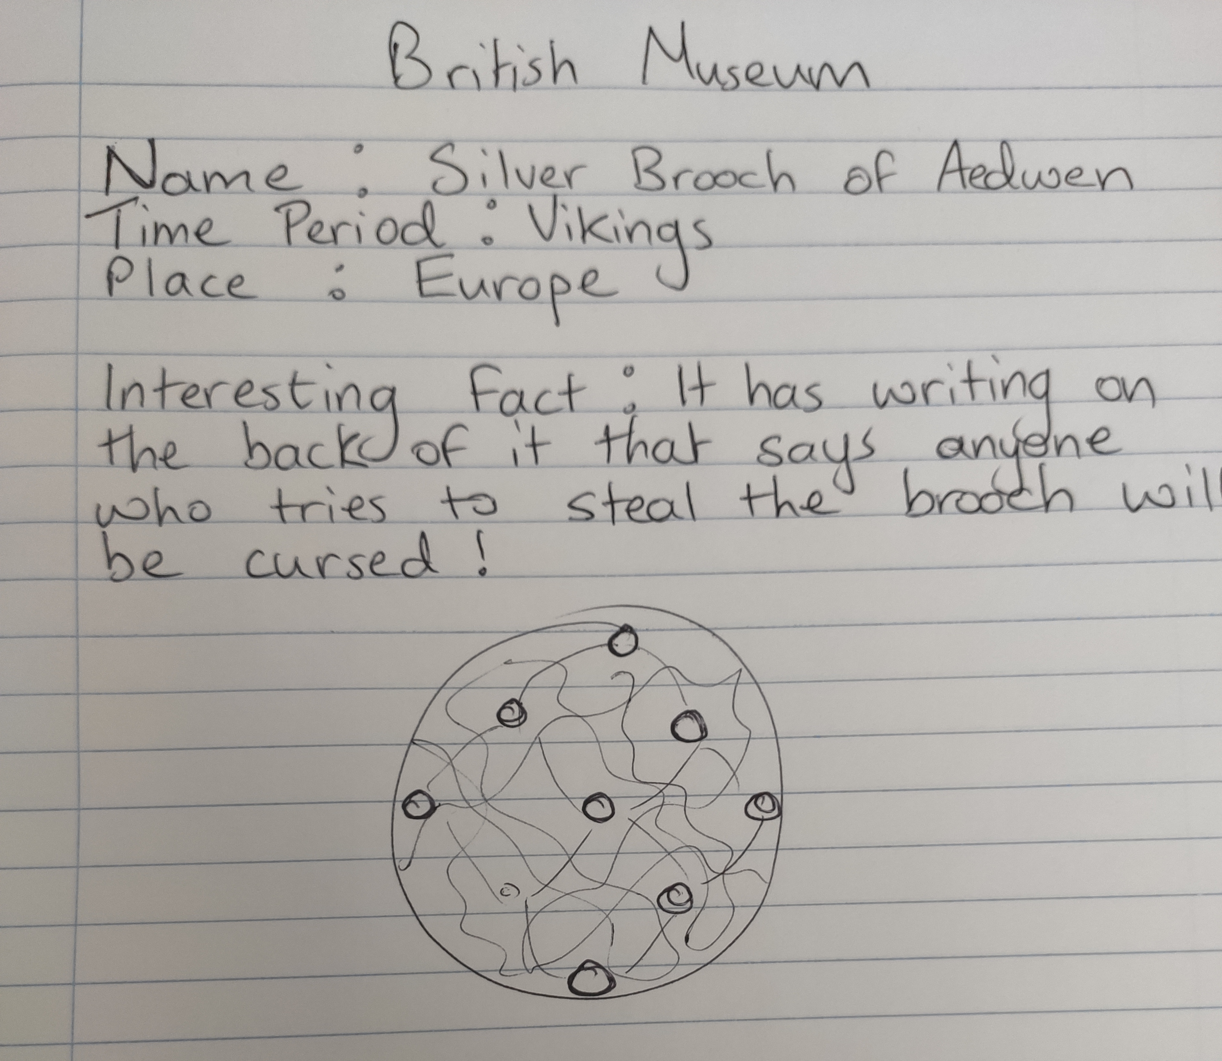

------------------------------------------------------------------------------------------------------------------------------------------------

5th June 2020
Ms O Dea’s PE Activity
Hi girls
So, today’s PE task is a dance. It’s not just for you but one for all the family to get involved in.

What I want you to do is to learn the dance from the Icelandic Eurovision song. If you would like to record yourself doing it you can send it on to the school mobile phone 086-1805158.

I have attached a clip from Ireland AM, where they teach you how to do the dance! There are only 5 steps involved, so it is very straightforward! Do you recognise the song?? It’s a real Summer song and so catchy!

Now have fun!!
Ms O’Dea
https://www.youtube.com/watch?v=TLCZJ6_jzSY

-------------------------------------------------------------------------------------------------------------------------------------------------------------------------
8th June 2020
Ms Holden’s Art Activity
Hi ladies,

Choose your favourite animal. Using a pencil, draw an outline of your animal on a page.

Get old magazines and newspapers. Rip colours into small pieces. Put some glue on a plate. Put glue on the white sheet. Press your pieces of coloured paper onto your white sheet. Fill in all the animal, don't leave any spaces.
Have fun!
The penguin is by my nephew Charlie and my sister made the giraffe.
Once finished, how was the process for you? Is there anything you would change, if you were to make a collage again? Why did you choose the animal you made?

Take care, Ms. Holden

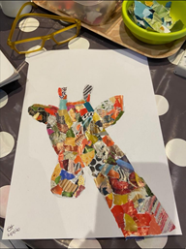 | 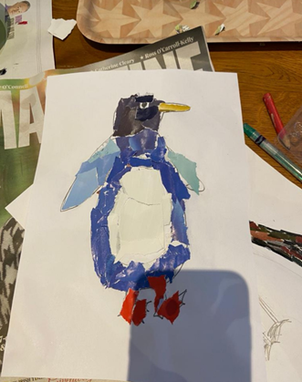

9th June 2020
Ms Farrell’s Drama Activity

I have picked 3 simple and fun drama activities for you girls to try out at home! We may be seeing some of you on the stage, TV or big screen in years to come!

Mirror Magic
(groups of 2)
A mirroring activity is especially enjoyable to do because there is no right or wrong way to do it – the goal is for you both to simply succeed! One of you will be the leader and the other will be the follower. The leader will perform motions, slowly at first, and the follower will mirror them. Kids will have a blast seeing how long they can go and what motions they can incorporate as they get more advanced!

Role model
(solo activity or with siblings)
It’s good for young actors to have role models. There are so many wonderful actors nowadays, that the only thing you have to do is to open a scene from any of their movies on YouTube and start to imitate their speech, pose, gestures, voice and emotions. It will be very hard at first, but the more you practice the better you’ll do it. Of course, it’s impossible
to copy everything, but try to pay attention to all details.

Tongue Twisters
(solo activity or with siblings)
Tongue twisters are typically a warm-up, but they are also a fun activity you can do just about anywhere. You are likely familiar with some old favourites such as the one about Peter Piper and his Peppers or Sally at the Seashore, but there are so many out there! You can memorize them and impress people with your skill! I have attached a list of tongue
twisters for you to try.

Tongue Twisters
Enjoy!! Word of warning, they get more difficult as you read down the list
Four furious friends fought for the phone
Cooks cook cupcakes quickly.
Fred fed Ted bread and Ted fed Fred bread
Each Easter Eddie eats eighty Easter eggs.
A slimey snake slithered down the sandy Sahara.
If two witches were watching two watches: which witch would watch which watch?
Does your sport shop stock short socks with spots?
Many mumbling mice are making merry music in the moonlight.
The boot black brought the black boot back.
I saw Susie sitting in a shoe shine shop.
Betty bought butter but the butter was bitter, so Betty bought better butter to make the bitter butter better.
If you notice this notice, you will notice that this notice is not worth noticing
A skunk sat on a stump and thunk the stump stunk, but the stump thunk the skunk stunk.
----------------------------------------------------------------------------------------------
10th June 2020
Ms Haughton’s PE Activity
Active Bingo:
You need:
- The bingo card attached
- A small object to throw on top of the card
- Some space to move
Instructions:
- Print off the Bingo card or display it on a phone or tablet screen.
- Throw your stone on the card and where ever it lands, complete that movement for 30 seconds.
(If you are using a screen, simply complete the exercises one at a time in any order you wish).
- Continue to work your way through the bingo card till you have completed every exercise.
- When you are finished, take a post-workout selfie and email it to your teacher, telling her how you got on. From Ms Haughton
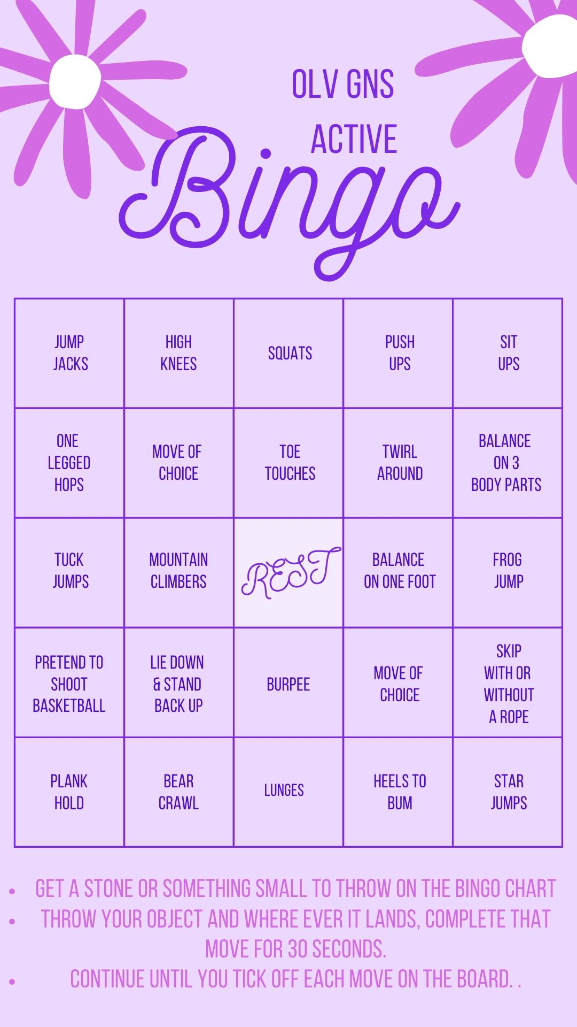
11th June 2020
Ms Smith’s Art Activity

Extend the Image Art Activity
Today we are going to be creating images and pictures using cut-outs, clippings and snippets from old magazines/newspapers/junk mail.
Expanding means to give a fuller picture or version.
It is a bit like having a zoomed in picture and then zooming out to reveal the whole picture.
We will be sticking a cutting onto a page and expanding the picture to what you imagine is happening when you “zoom out”. It can be as realistic or as imaginary as you like!
What you need
- An old magazine/newspaper/junk mail/leaflet.
- Scissors
- Glue/Sticky tape
- Plain white paper
- Colours (whatever you have at home; crayons/pencils/markers/paints)
Method
- Flick through the old magazine/newspaper/junk mail/leaflet. Look for images that have colour and something of interest in them.
- When you find an image you’re happy with, draw a small rectangle or square around a snippet of the image that you like. Cut this out and put it safely to the side. [You can gather one image or more if you want to do more than one picture.]
- Place your plain page in front of you, you choose if you want your picture to be landscape (horizontal) or portrait (vertical). Pick one cutting that you have and place it on your page.
- Try it in a few different spots around the page: top, bottom, middle, to the side, centred, a little off-centre. Up to you.
- Stick the clipping down where you wish. This is your “zoomed in” image.
- Now imagine that you “zoom out” and expand your image. Draw and create your picture to fill the page.
I’ve added some examples, scroll down to check them out. These may inspire you and give you ideas but try and come up with your original ideas!

Enjoy and have fun,
Ms Smith

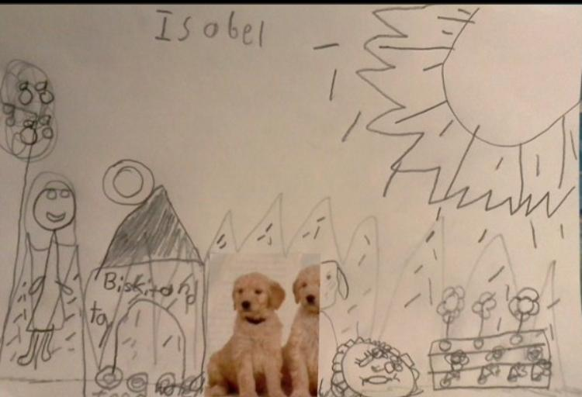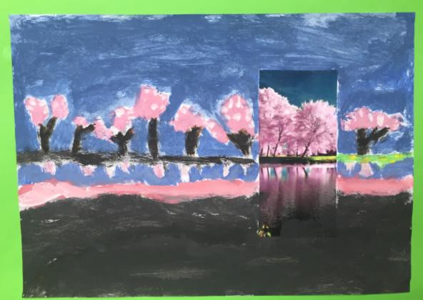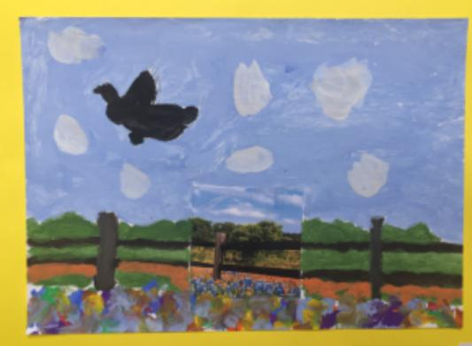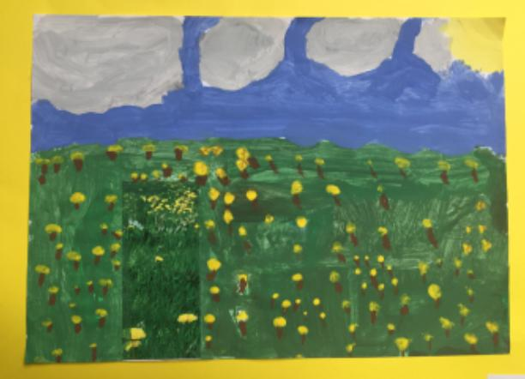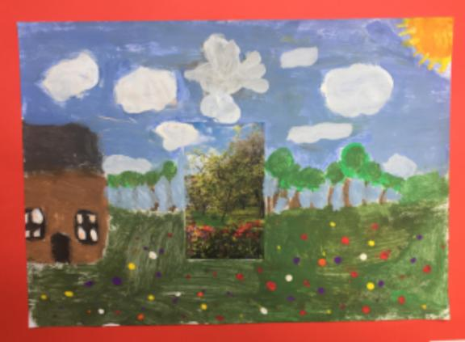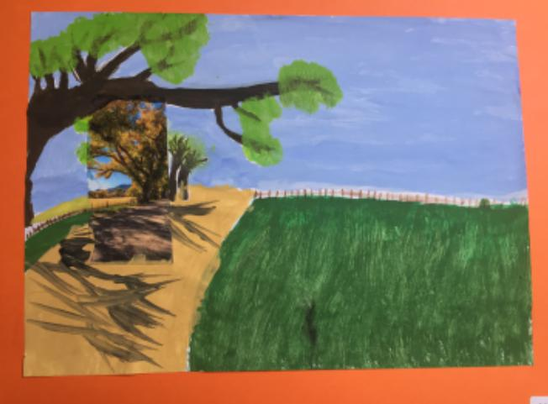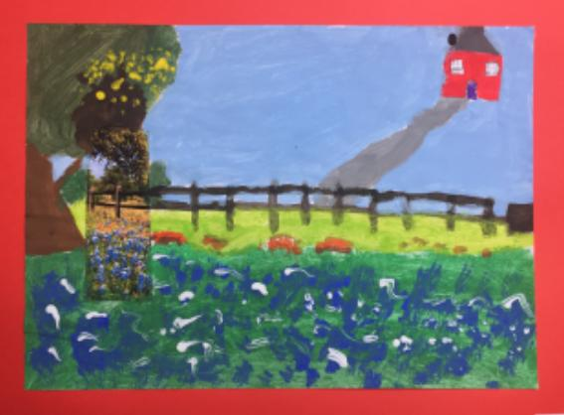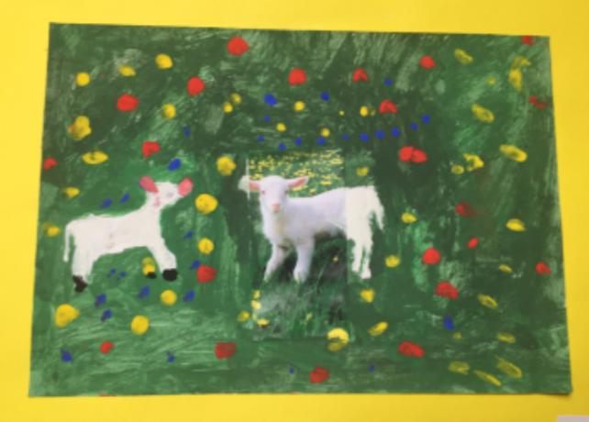

---------------------------------------------------------------------------------------------------------------------------------
12th June 2020
Ms Bourke’s Geography Activity

Geography UNSCRAMBLE!!

Click the link: https://www.sciencekids.co.nz/geography.html (on our Resources Page- Geography)
Scroll down to Quizzes (orange colour)
Click Geography Unscramble

Pick one or as many as you like! Enjoy UNSCRAMBLING..(and the answers are underneath each one!!)
Have fun!
Ms Bourke

