Class Level: 5th Class
 | Monday15th June | Tuesday 16th June | Wednesday 17th June | Thursday 18th June | Friday 19th June
Gaeilge | Every day, please spend 15-20 minutes practicing your Gaeilge using some of the suggestions on the online resources section of the website.  http://www.olvgns.ie/gaeilge-resources.html
English | Correct EIP  Poetry Exercise see below | Correct EIP  Poetry Exercise see below | Correct EIP  Poetry Exercise see below | Correct EIP  Poetry Exercise see below | Correct EIP  IXL
Ms Fleming’s English Group | Read: https://www.funbrain.com/books/diary-of-a-wimpy-kid/page/2 Mon.: p. 122-132  Mon.: Idioms: https://www.abcya.com/games/hold_the_phone | Tues.: Read: Same website as Monday p. 133-143,  Past Tense: https://www.abcya.com/games/journey_to_past_tense | Wed.: Read: Same website as Monday p. 144-154, Nouns and Verbs: https://www.abcya.com/games/nouns_and_verbs | Thurs.: Read: Same website as Monday p.155-156, IXL | Fri.: Read: Same website as Monday p. 166-176, Homophones: https://www.abcya.com/games/pancake_panic_homophones
Maths | Correct MM  Busy at Maths P 184 Q1&2 | Correct MM  Busy at Maths P 184 Q3 | Correct MM  Busy at Maths P 185 Q 4&5 | Correct MM  Busy at Maths P185 Q6&7 | Correct MM  IXL
Ms Fleming’s Maths Group | Mon.: MM. Wk.34 Mon. &Tues. p.101, Tables:x4, BAM: p.5 Q. 3, 4 | Tues.: MM. Wk.34 Wed &Thurs. p.102 Tables:x4, BAM: p.5 Q. 6, 8, 9 Correct Q. 8 with calculator | Wed.: MM. Wk.34 Friday p. 103, Tables:x4, BAM: p.6 Q. 1-5 | Thurs.: IXL | Fri.: Multiples: https://www.abcya.com/games/number_ninja_multiples, Fractions: https://www.abcya.com/games/adding_fractions
SPHE |  | Check the website for a well-being task set by a different teacher every day.  http://www.olvgns.ie/daily-task.html
Daily Activity | Ms Callinan’s Music Activity | Ms Fleming’s Science Activity | Ms Brennan’s Art Activity | Ms Ferriter’s History Activity | Ms Malone’s PE Activity

 | Monday 22nd June | Tuesday 23rd June | Wednesday 24th June | Thursday 25th June | Friday 26th June
Gaeilge | Every day, please spend 15-20 minutes practicing your Gaeilge using some of the suggestions on the online resources section of the website.  http://www.olvgns.ie/gaeilge-resources.html
English | Correct EIP  My Home Learning Time Capsule Complete 2 pages. This document is attached.  - How I feel  - Letter to Myself talking all about Lockdown and what life has been like. There is a template at the end of this document.  If you don’t have a printer you can do it in your copy or on a sheet of paper | Correct EIP  My Home Learning Time Capsule Complete 2 pages,  - My Family  - Hands and Paws | Correct EIP  My Home Learning Time Capsule  - Fun Things I am doing to keep busy  - Connecting with Others | Correct EIP  My Home Learning Time Capsule Interview page | You’ve made it and today you can take a break, you could try some games on IXL or else hopefully go out and enjoy (hopefully) sunny weather!!
Ms Fleming’s English Group | Mon.: Read: https://ww w.funbrain.com/books/diary-of-a-wimpy-kid/page/2 p.177-187, Parts of Speech: https://www.abcya.com/games/parts_of_speech | Tues.: Read: Same website as Monday p. 188-198, Wordsearch: https://www.turtlediary.com/game/body-parts-word-search.html | Wed.: Read: Same website as Monday p. 199-201, Reading Quiz: https://wordville.com/columbus/reading/Columbus1492.html | Thurs.: Read: Same website as Monday p. 202-212, Hangman! https://www.turtlediary.com/game/clothes-hangman.html https://www.turtlediary.com/game/colors-hangman.html | Fri.: No work today girls! Well done for ALL your HARD WORK! I am very proud of you all. I hope you have a FABULOUS summer
Maths | Correct MM  Today complete the Code Breaker Challenge, you don’t need to print it out you can do it in your copy. The sheet is attached!! | Correct MM  Today’s games are all about Fractions, try them out and see how you get on!!  You will need a square piece of paper for this one and follow the instructions on the clip!!  https://www.youtube.com/watch?v=ptCTq2aAeo0  https://nrich.maths.org/8283  https://nrich.maths.org/4519 | Correct MM  Today’s game is all about revising your tables try this game out!  https://www.topmarks.co.uk/maths-games/hit-the-button  Also if you feel like a bit of a challenge why don’t you play Countdown, this is one of my favourite games!!  https://nrich.maths.org/6499 | Correct MM  Today is all about Mental Maths, listen to these clips and try and work out the answers!! Try without a calculator or paper!!  https://www.youtube.com/watch?v=H5PmB56zUmM  https://www.youtube.com/watch?v=DnSXKWdU-2k  https://www.youtube.com/watch?v=meIO97tXv2o | You’ve made it and today you can take a break, you could try some games on IXL or else hopefully go out and enjoy (hopefully) sunny weather!!
Ms Fleming’s Maths Group | Mon: MM. Wk. 35 Mon & Tues. p. 104 Tables: x6, BAM: p.6 Q.6-10 | Tues.: MM. Wk.35 Wed &Thurs. p. 105 Tables: x6, BAM: p.6 Q.11-15 | Wed.MM.Wk.35 p.106 Fri, Tables: x6, BAM.: p.6 Q.16-20 | Thurs: Time: https://www.abcya.com/games/telling_time, Bingo: https://www.abcya.com/games/math_bingo | Fri.: No work today girls! Well done for ALL your HARD WORK! I am very proud of you all. I hope you have a FABULOUS summer
SPHE |  |  |  | Check the website for a well-being task set by a different teacher every day.  http://www.olvgns.ie/daily-task.html
Daily Activity | Ms Cassidy’s Music Activity | Ms Farrell-McCabe’s PE Activity | Ms Behan’s Science Activity | Ms Holden’s Art Activity | Ms Greene says to have a special End of Year party at home!!!

English Poetry Exercises

Monday 15th June
Imaginative word choices in poetry

Poets choose verbs, adverbs and adjectives carefully to make their writing precise, interesting and exciting. Because poems often have fewer words than stories, each word has to have the biggest possible impact on the reader.
Read the poem. Then complete the activity below.

‘The Crocodile’ by Lewis Carroll

How doth the little crocodile
Improve his shining tail,
And pour the waters of the Nile
On every golden scale!

How cheerfully he seems to grin!
How neatly spread his claws,
And welcome little fishes in
With gently smiling jaws!

- Find and write from the poem
  - one verb b. one interesting verb c. one imaginative adjective

- Think of another verb, interesting verb, and imaginative adjective that could replace the words you chose above.

Alliteration is when words that are close together begin with the same sound.
- Examples: Billy the bull barely bounced over the bar!
- Cuddling cats on a cold night comforts me!

Now try the task below!

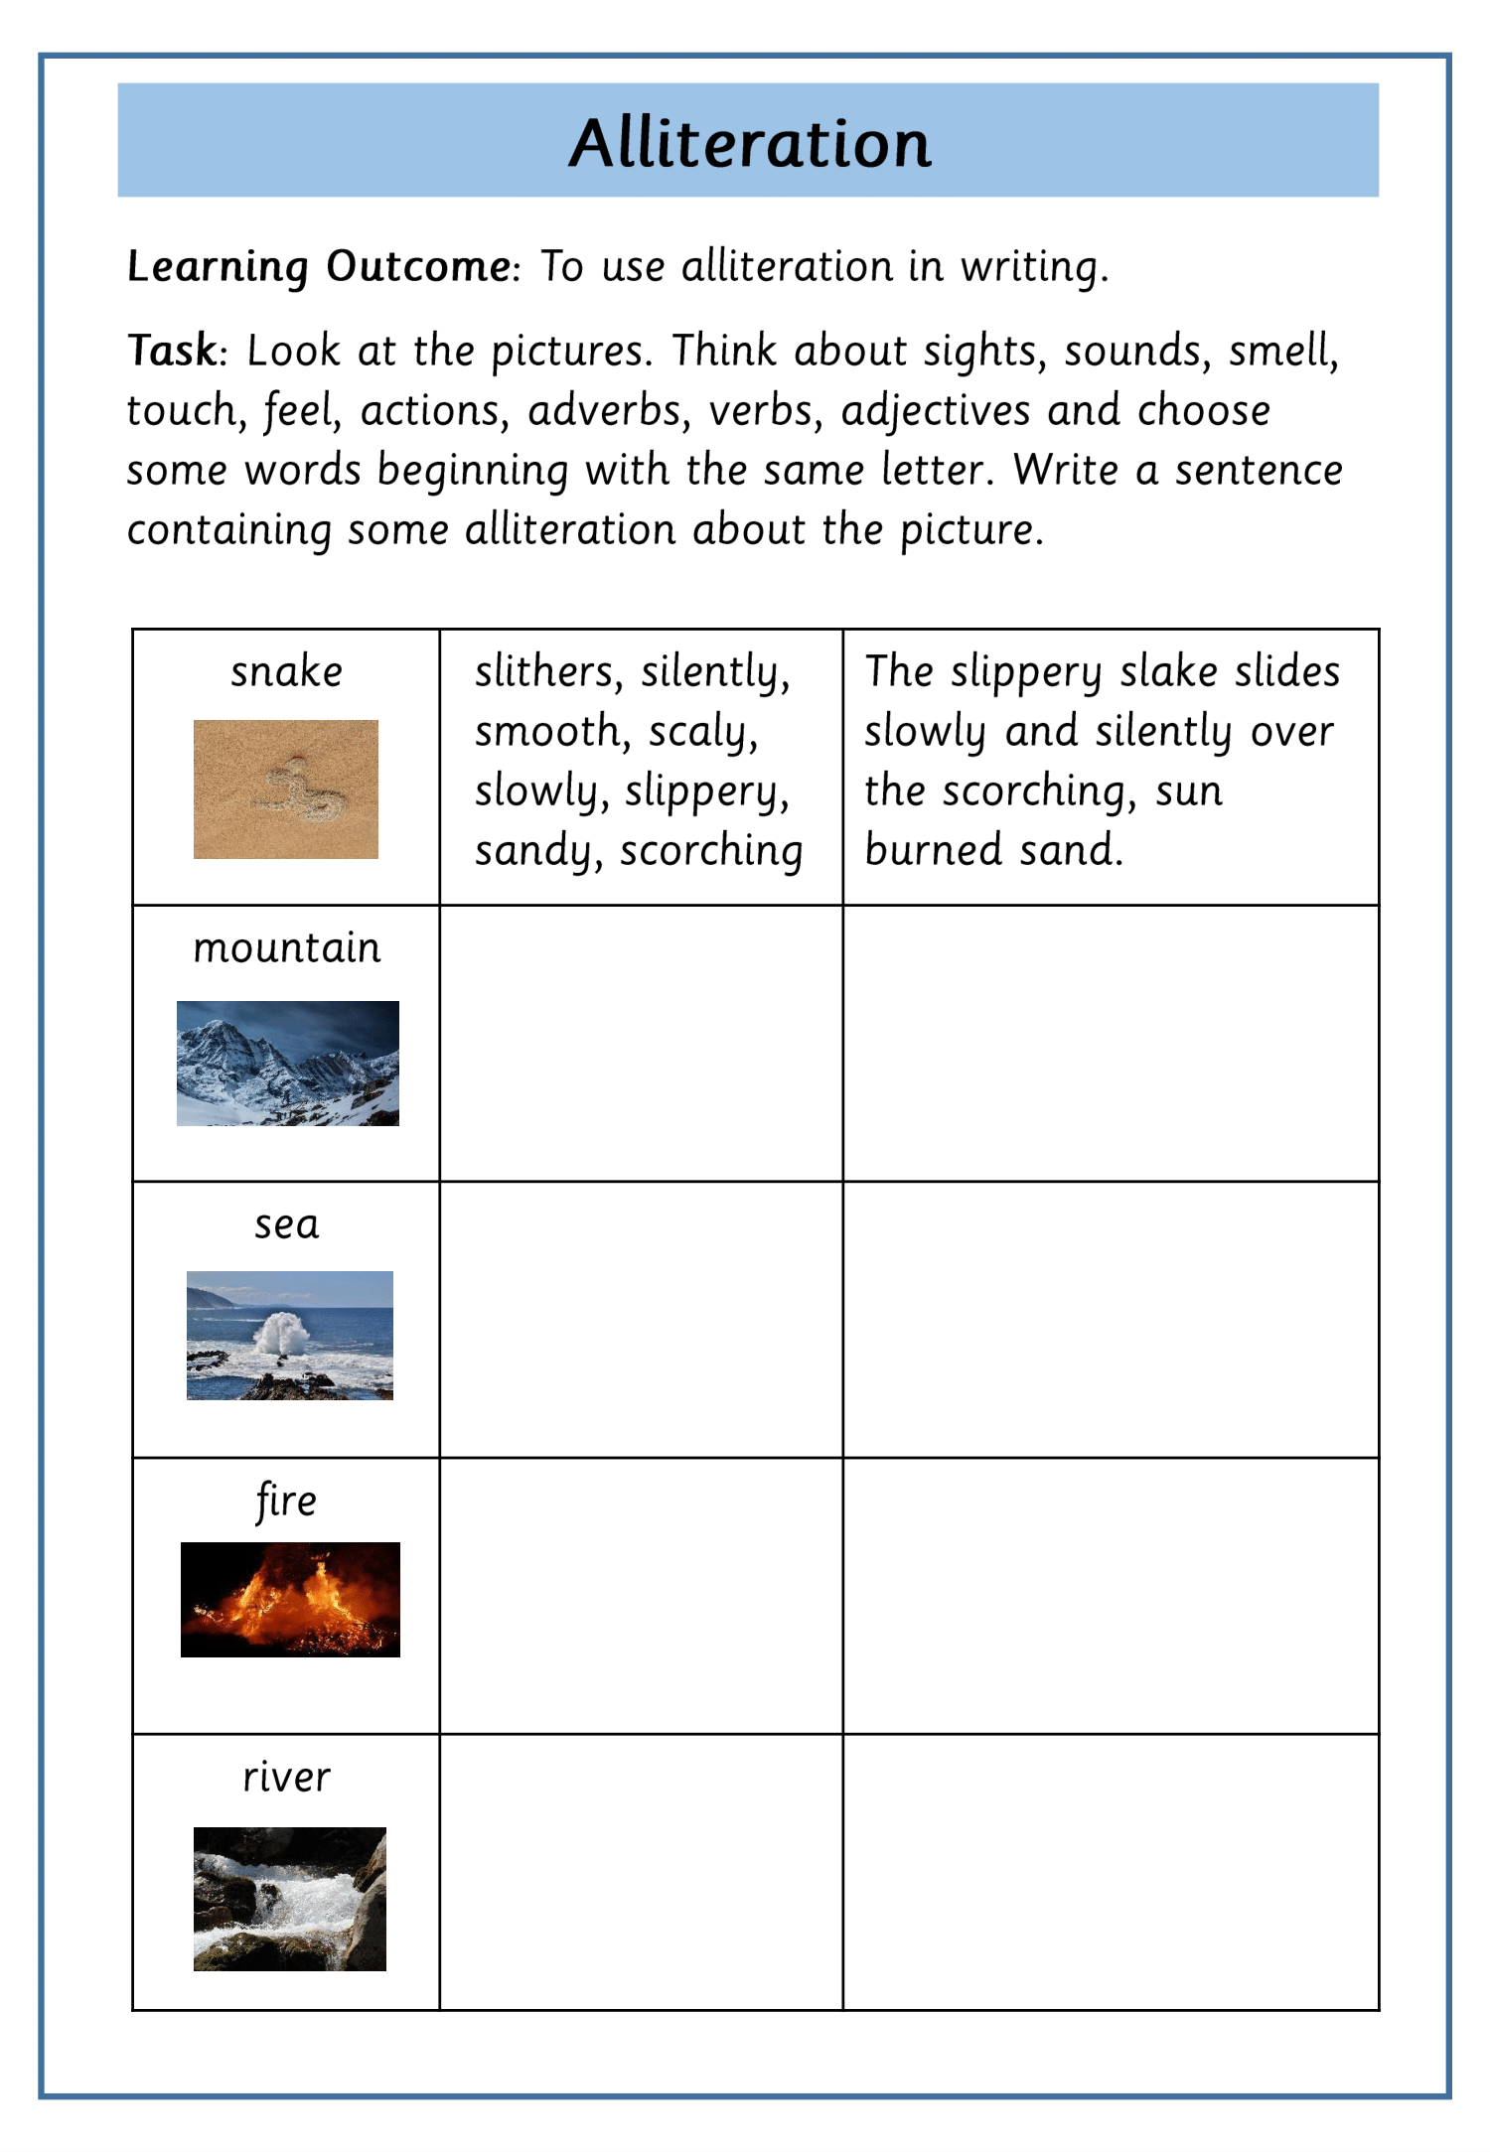

Tuesday 16th June

Metaphors and similes

A metaphor describes something as if it is something else

Example:
- A river of tears ran down her face.
- A wave of terror crashed over him.

Write out the meaning of each of these metaphors in your copy.
- He’s my knight in shining armour!
- This beach is heaven.
- Joan of Arc had the heart of the lion.

A simile compares things using ‘as’ or ‘like’

Examples
- He ran as quick as lightning
- She sang like an angel

Write similes to describe the following.

- The feel of sand beneath your feet is as soft as _________.
- The sound of waves crashing on the shore is as loud as ______.
- The taste of ice is like ______.
- The warmth of the sun on your skin is like ______.

Wednesday 17th June

Writers choose words carefully to make writing precise, interesting, exciting and to create an impact to the reader.
When you edit your writing, you can improve your word choices and add more exciting language features, such as similes, metaphors and alliteration.
Look at the example below. The second sentence uses stronger verbs, more descriptive adjectives and more interesting and precise nouns, as well as a simile, a metaphor and alliteration.
This sentence is boring!!

I stood on the deck of the ship as waves pulled us.

I struggled to remain upright on the slippery deck of the shuddering ship as the demon waves pulled us away from the shoreline like a child’s toy boat.
By adding a little more detail and some, how much better is the sentence

Edit and rewrite the following sentences so they have more impact.
- I walked along the beach alone.
- We watched the scary movie in the dark.
- The fox jumped over the stream and ran across the field.
- The rain fell heavily and the wind blew strong.

Thursday 18th June

So today we are going to look at Limericks, they are a very particular type of poem! They are light-hearted, funny poems with several common features.
Look at this poem
Lines 3 and 4 are
shorter, with the
same number of
syllables (5-6).

There once was a young bat from Ealing,
Lines 1, 2 and 5 are longer and have approximately the
same number of
syllables (usually
8-10) in each.
Who always would hang from the ceiling.
He couldn’t wear a hat,

But could dance like a cat,
And said, “What a wonderful feeling!”
Limericks follow a typical rhythm:
di DUM di di DUM di di DUM dum (3 beats)
di DUM di di DUM di di DUM dum (3 beats)
di DUM di di DUM (2 beats)
di DUM di di DUM (2 beats)
di DUM di di DUM di di DUM dum (3 beats)
Now it’s your turn to write a Limerick about something, it could be school, summer holidays!

- There once was a from ,
- Who .
- He ,
- And/but/then .
- .

Monday 22nd June

Letter to My Future Self
Write a letter to your future self and draw a picture of yourself in the box. Open it at the end of the year and see if anything has changed.

Date

Dear

