BEFORE YOU START ANY OF YOUR WORK: PLEASE FILL IN THIS SURVEY FOR MS GREENE AND THE TEACHERS: https://forms.gle/7SjbC9uLXW7HiWBbA (You might have to copy and paste the link if you are looking at this on a phone. But don’t worry, Ms Greene is going to text the link to your parents as well if you are having trouble with it here!)
Maths | Topic | Mental Maths | IXL | Other
5th May’20 | Lines and Angles | Week 30  Pages  89 -91 | T.5  T.6  G.3  K.1 | Look at the pictures below:  Talk Time Which lines are parallel?  Can you explain your answer in your copy.
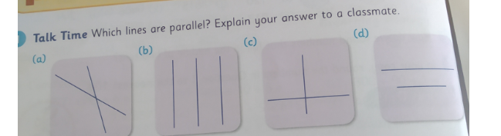
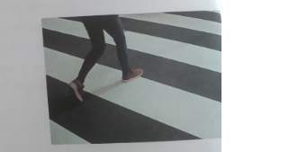

Identify four sets of parallel lines in your house
Record the parallel lines by drawing pictures in your copy.
Remember when drawing parallel lines, keep them the same distance apart. They must never touch.

Maths | Topic | Mental Maths | IXL | Other
11th May’20 | Lines and Angles | Week 31  Pages  92 - 94 | T.7  T.8  G4.  K.2 | Look at the pictures and answer the questions below.

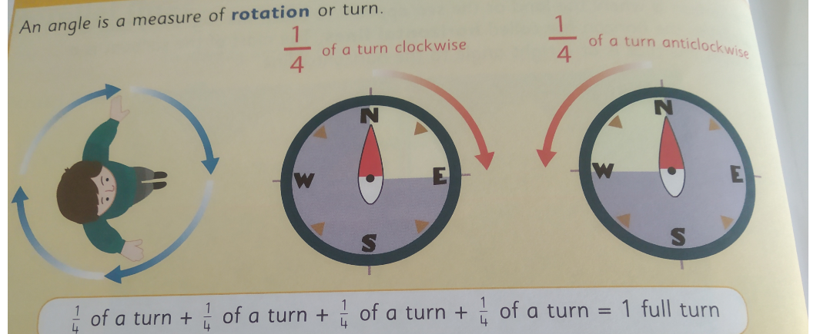
Predict and record where you will be facing if you make these rotations: The word Predict means Estimate. Do you remember what estimate means? (Guess)
- Quarter of a turn clockwise 2. Half a turn clockwise.
- Half a turn anticlockwise 4. Quarter of a turn anticlockwise
- A full turn clockwise 6. A full turn anticlockwise
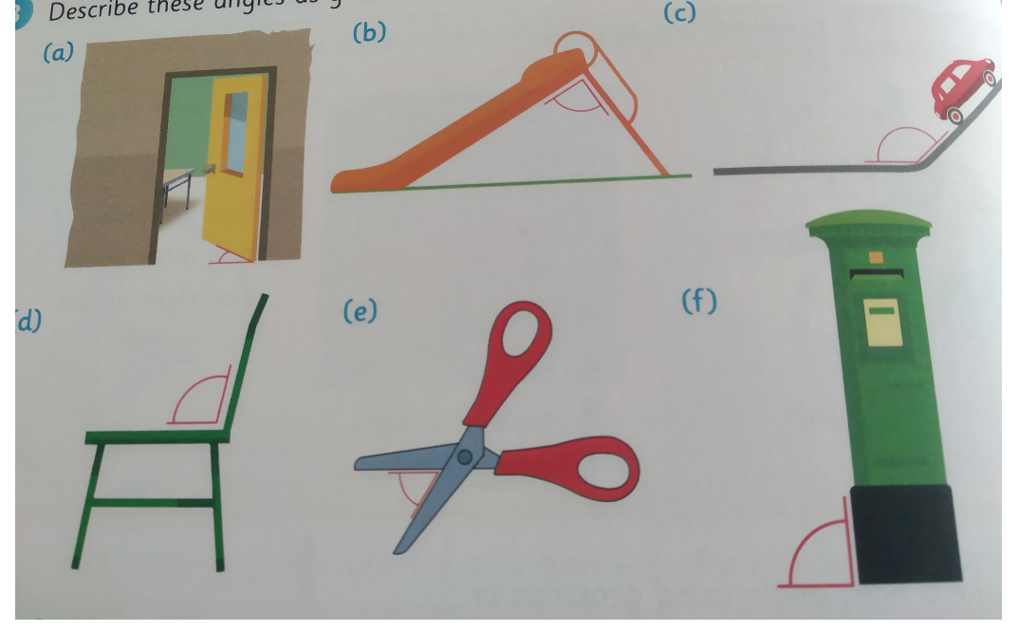
Describe these angles as:
Greater than, Less than Or equal to a right angle

Find three examples of each of these lines and angles in Colm’s house. A. Horizontal lines B. Vertical lines C. Parallel Lines D. Right angles.

