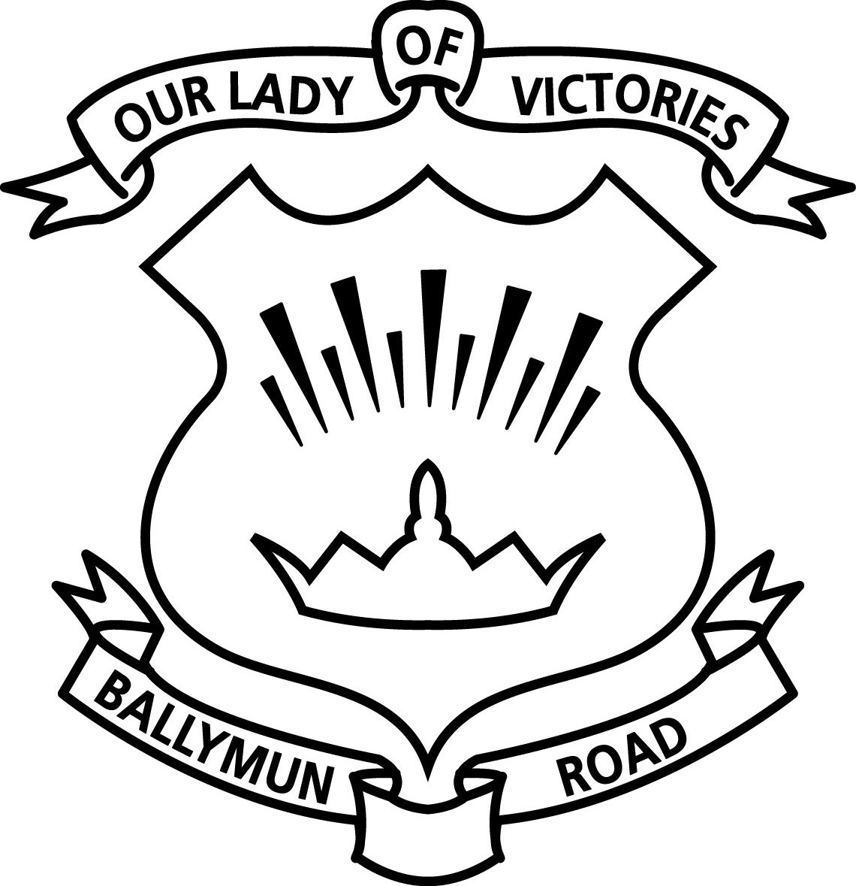
OLV GIRLS SCHOOL
NEWSLETTER WEEK 5

Wellbeing in School: We are continuing to roll out the Weaving Wellbeing Programme with our classes. This is our second year engaging with it and it really is a wonderful programme. I would encourage you all to chat about these lessons with your daughters.
We are receiving more and more phone calls from parents/guardians on a daily basis, informing us of incidents happening in the school during the school day, as reported to them by their daughters on their return home, which I am very grateful for. However, as a staff we feel that this is a direct fallout of the school closure. The children have forgotten how important it is to speak to an adult here if something is bothering them. Yesterday, I sent a video message to all children in the school reminding them of what it is like to be part of the fantastic OLV Family. The girls’ emotional wellbeing is as important to us here in school, as it is to you at home. When they are in school with us here, the adults are in loco parentis. This is something that the staff will be focusing on over the coming weeks.
Please encourage the children to speak out if something is bothering them. Please ask them which adult in the school they could talk to about something that is making them upset- this was a reflective exercise the whole school engaged in yesterday.

Planned on-site 2nd and 3rd Class Parent/Guardian Meetings: Unfortunately, due to restrictions on hosting organised indoor events under Level 3 of the National Framework for living with Covid-19, these meetings have been cancelled.

Whole School Class Meetings: Teachers from 2nd-6th Class will shortly send all parents/guardians a link to a video that will answer most questions parents/guardians have about life in OLV Girls’ School and what is to be expected in their new class level. Any questions that remain unanswered can be emailed directly to the class teacher at msx@olvgns.ie and we will create an FAQ document if necessary. (please note: msjsmith in 5th Class and mscsmith in 6th Class)

Social Distancing at Home Time: As per government guidelines, please maintain 2m from all other adults when collecting your children at home time or wear a face-covering.

Homework: Next week we will begin setting homework for the children for the first time this year. We are delighted that we now have an opportunity to review homework practices as they stood previously. Following reflection on a whole school level, we would like to ensure homework is being completed at home for the correct reasons;
- that parents/guardians are aware of their daughter’s learning style, her level of ability and of the work going on in classrooms.
- that homework is used as an assessment tool i.e. do the children understand what is being taught in school (assessment of learning) and what needs to be taught again/next (assessment for learning).
We will begin by setting Reading and Phonics homework only for the next three weeks. Your daughter’s class teacher will be in touch. Maths homework will follow.

Kind Regards,
Lorna Greene
School Principal

