Maths | Topic | Mental Maths | IXL | Other
15th – 19th June 2020 | Patterns | Week 36  Pages 107 - 109  Remember to use rough worksheets to work out your sums and don’t forget to use TOUCH MATHS POINTS | P 3  O 6 | Look at the pictures below.  Read and answer questions
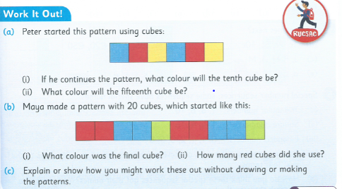

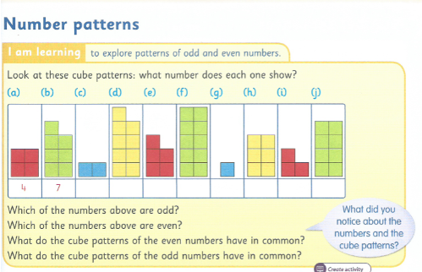
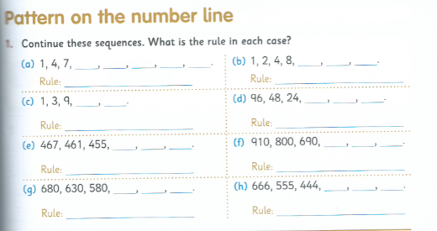

Maths | Topic | Mental Maths | IXL | Other
22nd – 26th June 2020 | Money | Week 37  Pages 110 - 112  Remember to use rough worksheets to work out your sums and don’t forget to use TOUCH MATHS POINTS  Keep up the Friday Tests if you can. | P 4  O 9 | Look at the pictures below.  Read and answer questions.

