Maths | Topic | Mental Maths | IXL | Other
18th - 22nd May ‘20 | Length | Week 32  Pages  95 – 97  Remember to use a rough sheet to work out your sums and don’t forget to use TOUCH MATHS POINTS  Keep up the Friday Tests. | F.5  R.11 | Look at the pictures below.  Picture One  Do question 1 and 2.  Picture Two  Do question 5.  Answers can be written in your copy.

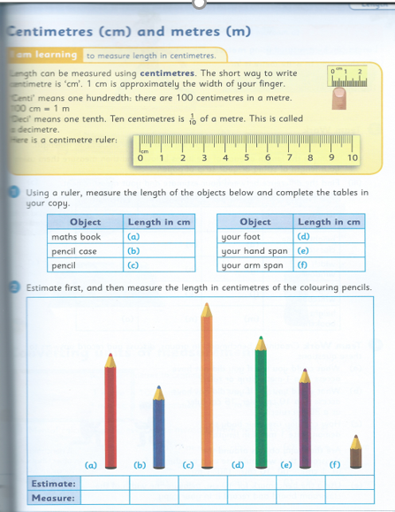

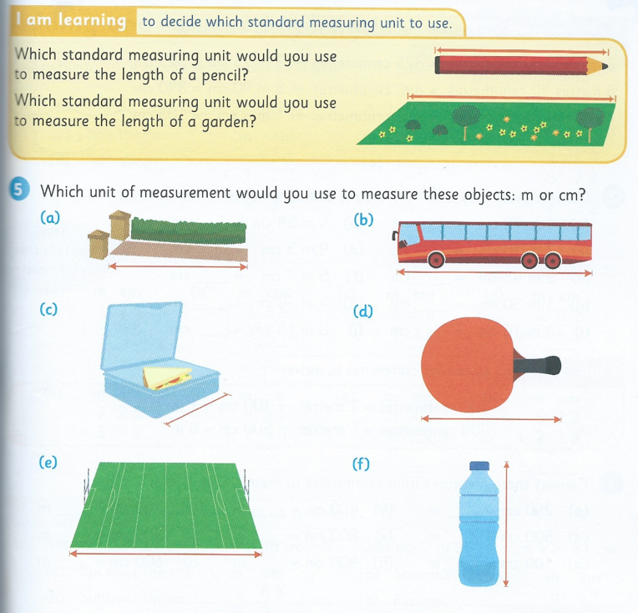

Maths | Topic | Mental Maths | IXL | Other
25th – 29th May ‘20 | Length | Week 33  Pages  98 – 100  No.13 on Monday - Remember to count the sides and that will help you remember the name of the shape  Remember to use rough worksheets to work out your sums and don’t forget to use TOUCH MATHS POINTS  Keep up the Friday Tests if you can. | F. 6.  Q.5 | Sum:  Addition worksheet  Do sums in question one  ( a, b, c d and e.)  Sums:  Subtraction worksheet.  Do sums in question 3  (a, b, c, d, and e.)  Answers can be written in your copy.

