Class Level: 4th Class
Hi girls!
It’s the last 2 weeks of school! Your last 2 weeks of 4th class! Just like the last work pack, there is less work to do than before the start of June. We’ve also included some nice activities for Week 2! Do not worry that there is less to do, you have done your very best since March and we are so happy with you all.
We have given you spellings which you can find if you scroll down below. We have also given you Maths from Action Maths and some fun Maths activities to try in Week 2, we have included this work at the end of this document.
We would really like you to get out and enjoy the weather and spend time in nature, you could even do your DEAR time outside in the sunshine!
You can send us photographs of your daily tasks or any work you’d like to show us that you’re proud of, we would love to see it! Please send it from a PARENT’S email during school hours to msbehan.olv@gmail.com or ms.jsmitholv@gmail.com .
All the best,
Ms Behan & Ms Smith
 | Monday 15th June | Tuesday 16th June |  | Wednesday 17th June |  | Thursday 18th  June |  | Friday 19th June
Gaeilge | Every day, please spend 15-20 minutes practicing your Gaeilge using some of the suggestions on the online resources section of the website.  http://www.olvgns.ie/gaeilge-resources.html
English | EIP  DEAR time 15mins  Spellings  Correct EIP (see answers on blog) | EIP  DEAR time 15mins  Spellings  Correct EIP (see answers on blog) |  | EIP  DEAR time 15mins  Spellings  Correct EIP (see answers on blog) |  | EIP  DEAR time 15mins  Spellings  Correct EIP (see answers on blog) |  | EIP  DEAR time 15mins  Spellings  Correct EIP (see answers on blog)
Ms Hanly’s English Group | Check for mistakes in the following spellings.  Watch out, some of them don’t have any!  Arrived  Loste  Trouble  Pain  Girafe  Fuzz  Weheel  Happilee  Rubber  Planc  Clouwd  Butter  Weight  Clothes  Moneey  Beecause | Write these words in alphabetical order:  Clock  Please  Shrink  Clothes  Snake  Flowers  Pear  Straight  Washing  Third  Finished  Different.  Now take four words and put them into sentences! |  | Same sound, different word.  Write down these words, then write another word beside it that sounds the same, but is spelled differently.  Sale  Chute  Paws  Waste  Billed  Bored  Flower  Scene  Way  Grown |  | Put this recipe in order, it’s all in a muddle!  *Put the mixture on to a floured table. Knead the dough for 5 minutes.  *Set the oven to 230°C/450°F/ Gas Mark 8. Put the flour, yeast and salt in the mixing bowl. Add the oil and water and mix together.  *Bake them for 15 to 20 minutes. When they are done, put them on a wire rack to cool.  *Shape the dough into rolls and put them on to a greased baking tray. |  | Click on the link below. All you have to do is write words in the boxes that match the description. For example ‘far away place’ = moon.  When you’re done click Read and your funny story will be created!  https://kids.nationalgeographic.com/games/funny-fill-in/funny-fill-in-scuba-surprise/
Maths | Mental Maths  Action Maths Sheet pg. 42 Q 1 - 3  Challenge (to try if you’d like) pg. 42 Q. 4 & 5  Correct Mental Maths (See answers on blog) | Mental Maths  Action Maths Sheet pg. 43 Q 1 (a,b,c)  Challenge (to try if you’d like) pg. 42 Q. 6 & 7  Correct Mental Maths (See answers on blog) |  | Mental Maths  Action Maths Sheet pg. 43 Q 1 (d,e,f)  Challenge (to try if you’d like) pg. 42 Q. 8 & 9  Correct Mental Maths (See answers on blog) |  | Mental Maths  Action Maths Sheet pg. 43 Q 2 (a,b,c)  Challenge (to try if you’d like) pg. 42 Q. 10 & 11  Correct Mental Maths (See answers on blog) |  | Mental Maths  Action Maths Sheet pg. 43 Q 2 (d,e,f)  Challenge (to try if you’d like) pg. 43 Q 3  Correct Mental Maths (See answers on blog)
Ms Hanly’s Maths Group | Click the link below and follow the instructions on screen. See if you can do this with a real pizza next time you have it for dinner!  https://www.starfall.com/h/geometry/pizza/?sn=math3 | Think back to your fractions from yesterday. Now do these!  ½ of 50=  2/4 of 30 =  ¼ of 4=  25% of 8 =  1/5 of €2.50=  1/10 of €8=  If you need help with these, just check your MM book! |  | Join the pairs of fractions that have to same value.  2/6  9/12  3/4  2/3  1/2  2/8  5/10  1/3  6/9  1/4  Can you come up with any of your own? |  | TRUE OR FALSE!  A square has four equal sides and four equal angles.  A rectangle has equal opposite sides.  A square is a 2D shape  A right angle is 90*  7x 3 = 25  100cm = 1m  100ml = 2ltr  50 minutes = 1 hour  The small hand on the clock is for minutes. |  | Maths all around me at home!  Find five different 3D shapes at home and draw a picture of them in your copy.  - Cube  - Cuboid  - Cylinder  - Sphere  - Cone  (Don’t forget, you can check in your MM books if it’s a bit tough)  Find and draw two things that are longer than one metre.  Write down three places that you can find numbers at home.
SPHE | Check the website for a well-being task set by a different teacher every day.  http://www.olvgns.ie/daily-task.html
Daily Activity | Ms Callinan’s Music Activity |  | Ms Fleming’s Science Activity |  | Ms Brennan’s Art Activity |  | Ms Ferriter’s History Activity |  | Ms Malone’s PE Activity

 | Monday 22nd June | Tuesday 23rd June |  | Wednesday 24th June |  | Thursday 25th  June |  | Friday 26th  June
Gaeilge | Every day, please spend 15-20 minutes practicing your Gaeilge using some of the suggestions on the online resources section of the website.  http://www.olvgns.ie/gaeilge-resources.html
English | EIP  DEAR time 15mins  Spellings  Correct EIP (see answers on blog) | EIP  DEAR time 15mins  Spellings  Correct EIP (see answers on blog) |  | EIP  DEAR time 15mins  Spellings  Correct EIP (see answers on blog) |  | EIP  DEAR time 15mins  Spellings  Correct EIP (see answers on blog) |  | SUMMER HOLIDAYS!  ☀️🥳
Ms Ferriter/ Ms Hanly’s English Group | Virtual Books!  Click on the link below to start reading your virtual book. Don’t foget to try follow along with the narrator!  https://pbskids.org/wordgirl/games/storybookadventure/becky-botsford/ | Virtual Book Continued…  Click on the link below and do the same as yesterday. Don’t forget to follow alond with the narrator.  https://pbskids.org/wordgirl/games/storybookadventure/wordgirl/ |  | Interesting Facts.  Click on the link below and read the facts about Dolphins.  Maybe afterwards, you can tell a friend, parent or sibling some facts. I bet they’ll be really impressed!  https://kids.nationalgeographic.com/animals/mammals/bottlenose-dolphin/ |  | Quiz Time  Let’s let our hair down for the last day. I’ve attached a link below and through it you can find so many quizzes!  You can do as many as you want, maybe see what answers the other girls get in theirs!  https://kids.nationalgeographic.com/games/personality-quizzes/ |  | No work today ladies! Well done for ALL your HARD WORK! I am very proud of you all and I hope you have a FABULOUS summer!
Maths | Mental Maths  Maths Trail (Find the Maths Trail at the end of the work pack)  Correct Mental Maths (See answers on blog) | Mental Maths  Summer Multiplication Colouring Sheet (Find these sheets at the end of the work pack)  Correct Mental Maths (See answers on blog) |  | Mental Maths  Maths Trail Cards - Take pictures of your Nature Maths Trail! (Find the Maths Trail Cards at the end of the work pack)  Correct Mental Maths (See answers on blog) |  | Mental Maths  Emoji Maths Challenge! (Find this challenge at the end of the work pack)  Correct Mental Maths (See answers on blog) |  | SUMMER HOLIDAYS!  ☀️🥳
Ms Hanly’s Maths Group | Test your tables!  https://www.coolmath4kids.com/quizzes/multiplication  I have given you one here, but I’d like if you tried two more numbers. You can pick which ones! | Test your division!  Don’t forget girls, that division is just repeated subtraction!  https://www.coolmath4kids.com/quizzes/division |  | Do you know your prime numbers?  https://www.coolmath4kids.com/math-games/math-fisher?tid=19 |  | Let’s end on an easy note…  You can pick your level and go from there!  https://www.funbrain.com/games/tic-tac-toe-squares |  | No work today ladies! Well done for ALL your HARD WORK! I am very proud of you all and I hope you have a FABULOUS summer!
SPHE | Check the website for a well-being task set by a different teacher every day.  http://www.olvgns.ie/daily-task.html
Daily Activity | Ms Cassidy’s Music Activity |  | Ms Farrell-McCabe’s PE Activity |  | Ms Behan’s Science Activity |  | Ms Holden’s Art Activity |  | Ms Greene says to have a special End of Year party at home!!!

Spellings Week 1: <-ic> | Spellings Week 2: Plurals with <-ar>
Daisy 1-6, Tulip 1-12, Rose 1-16  - picnic  - magic  - comic  - music  - attic  - panic  - public  - Arctic  - traffic  - elastic  - frantic  - terrific  - magnetic  - clinic  - athletic  - fantastic | Daisy 1-4, Tulip 1-8, Rose 1-12  - liar  - pillar  - altar  - dollar  - collar  - cellar  - beggar  - burglar  - grammar  - sugar  - popular  - particular  *There are less spellings this week as we do not want you to have to do work on the last day of school!

Scroll down for Maths week 1 and Maths week 2!!!!

Week 1 Maths:
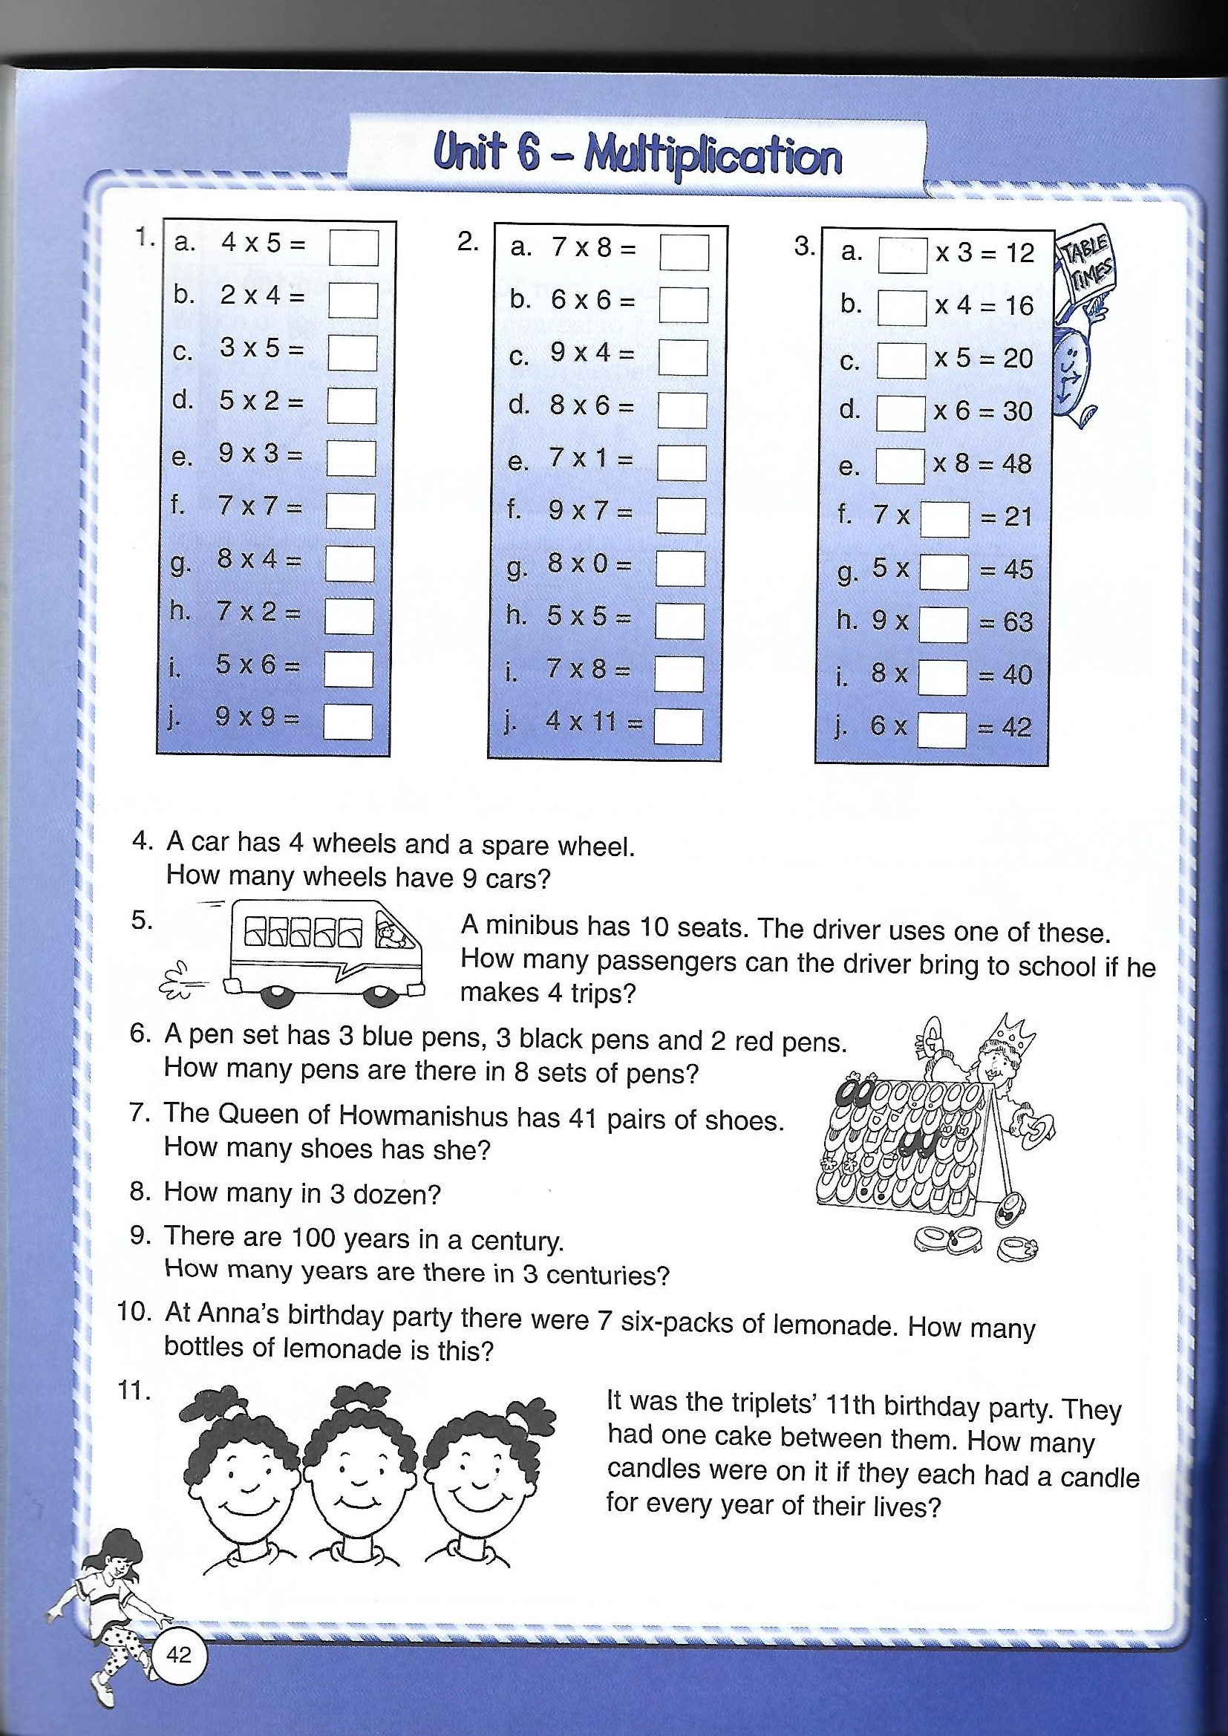
Action Maths pg. 42 & 43

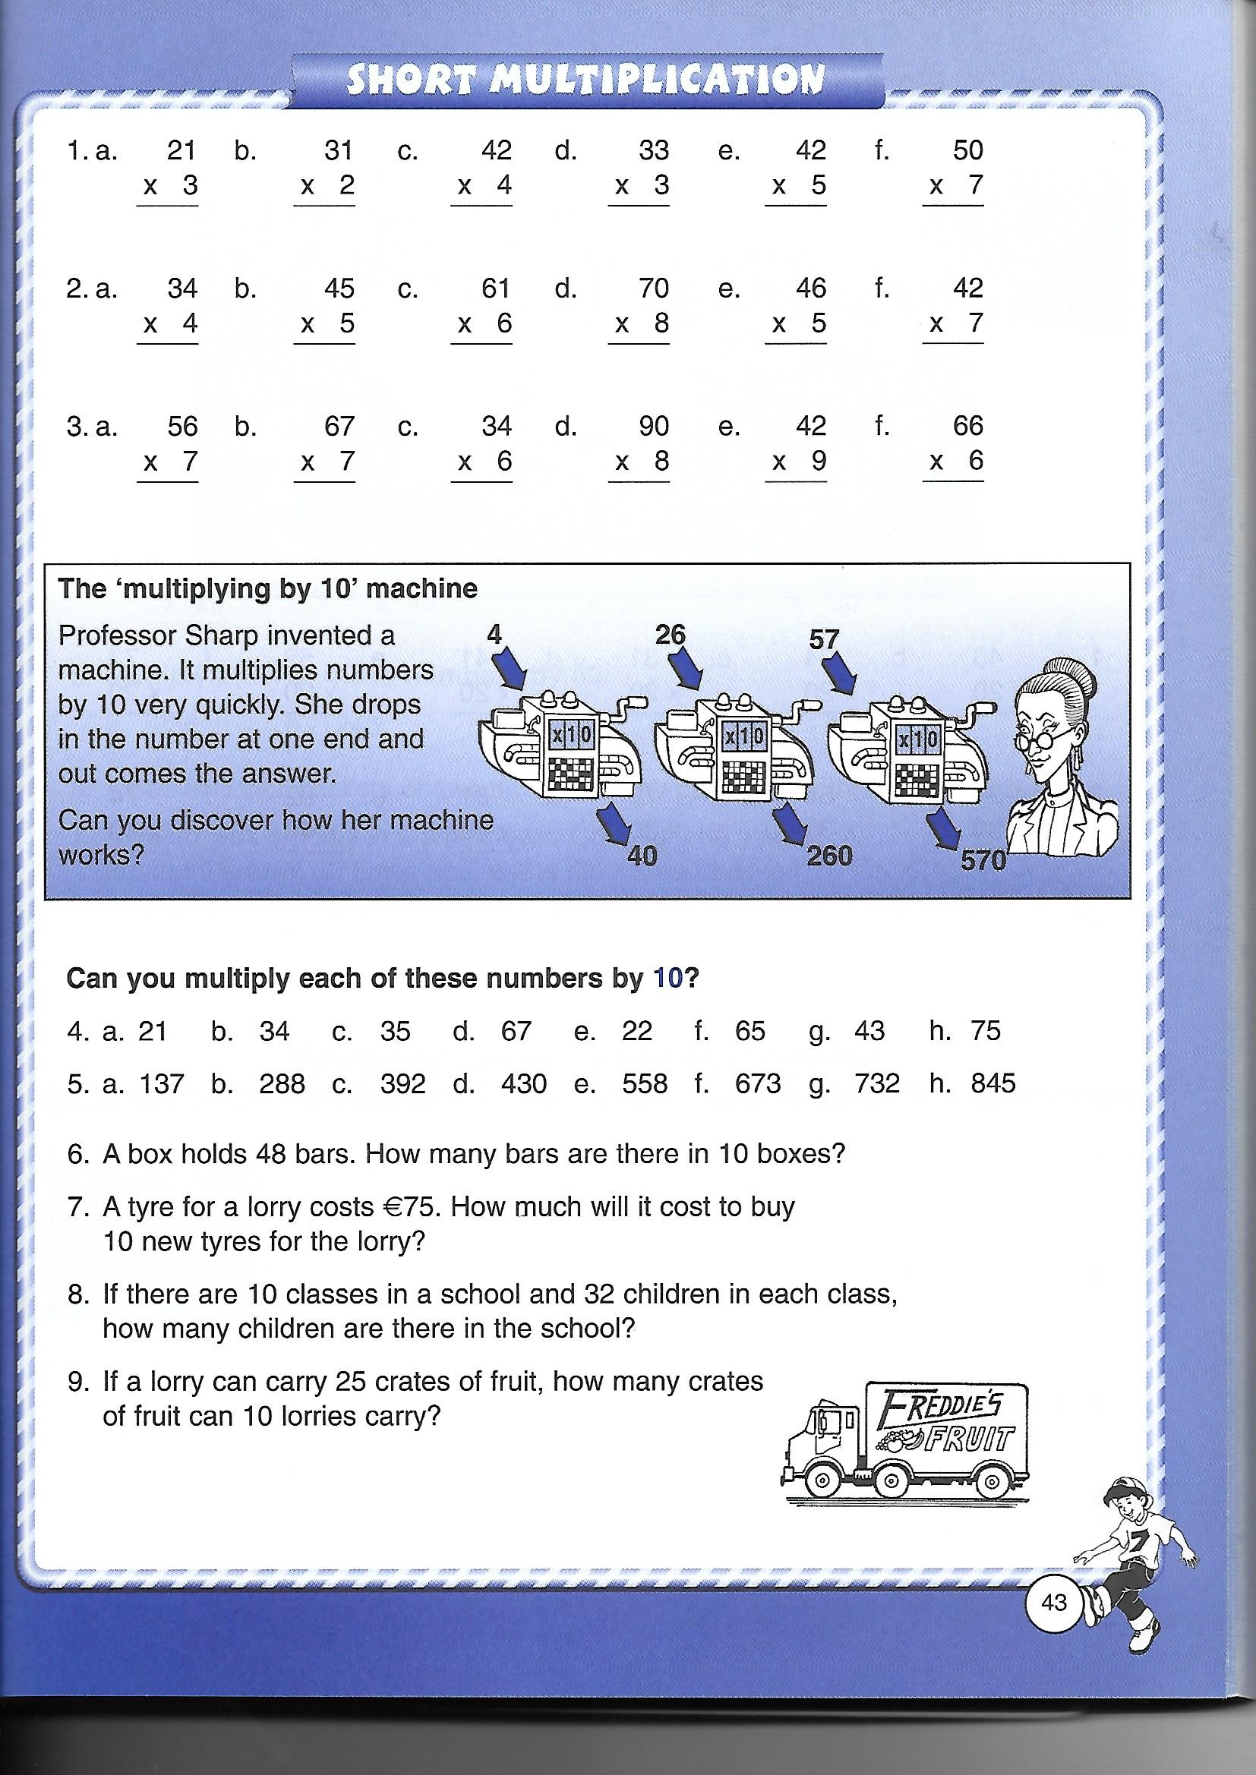

Week 2 Maths:
Monday:
Maths Trail (You can print this out or write the answers into your copy)
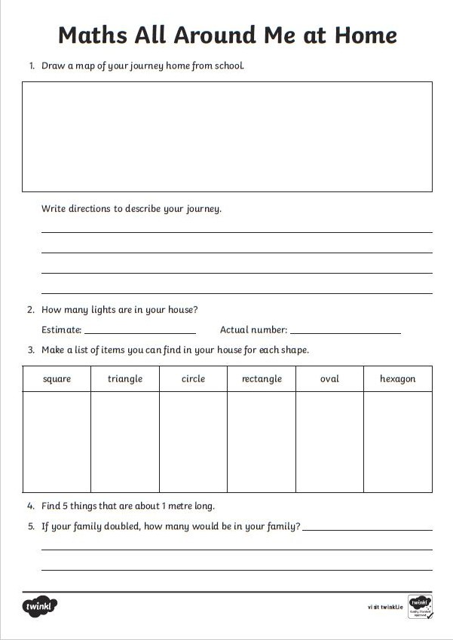

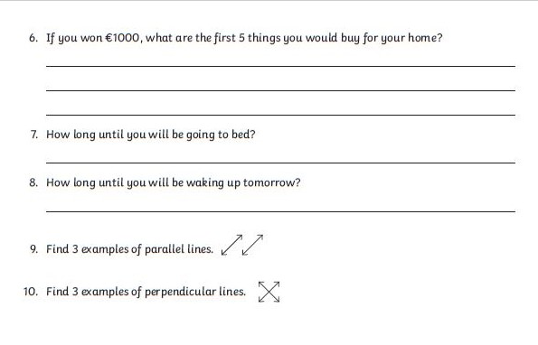

Tuesday:
We have 3 Summer Multiplication Mosaics for you to try! You can use your school journal on page 15 to help you with your Times Tables. What images do they make?
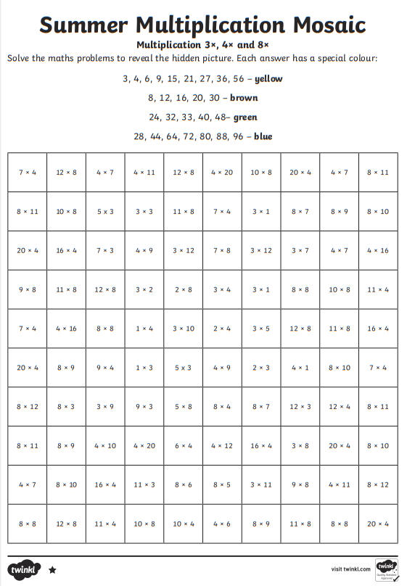

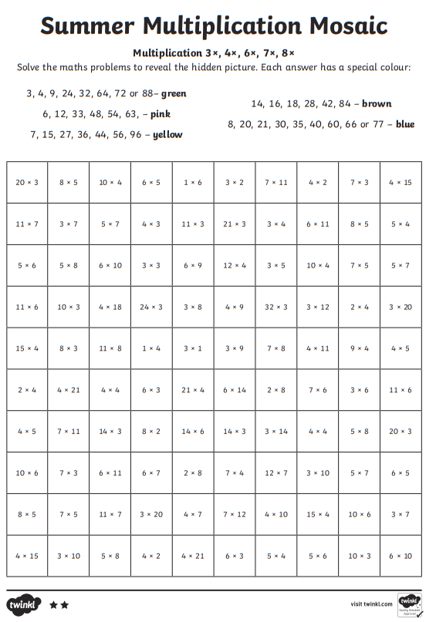
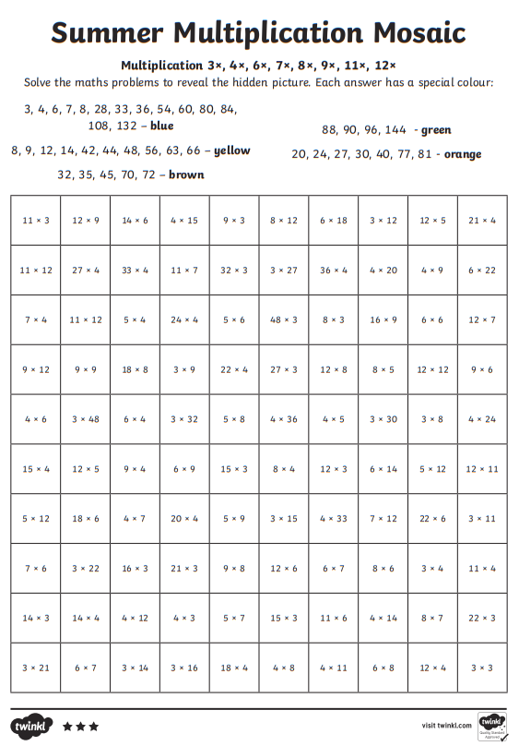
Wednesday:
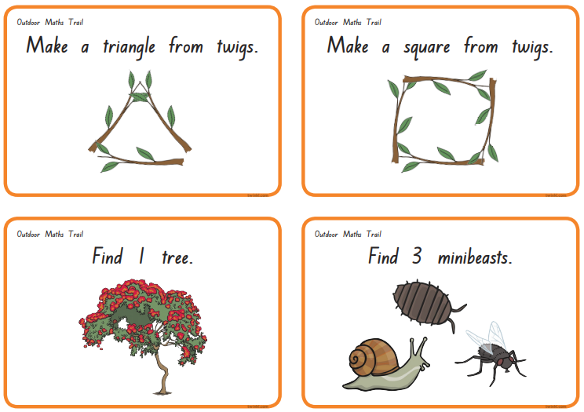
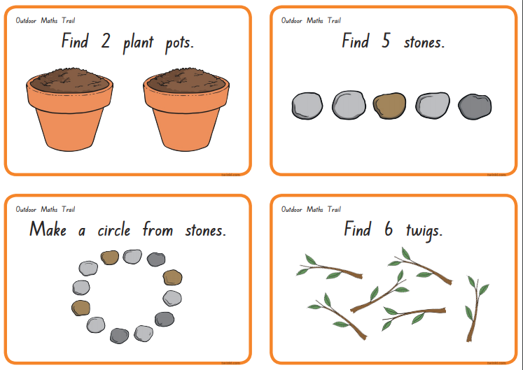
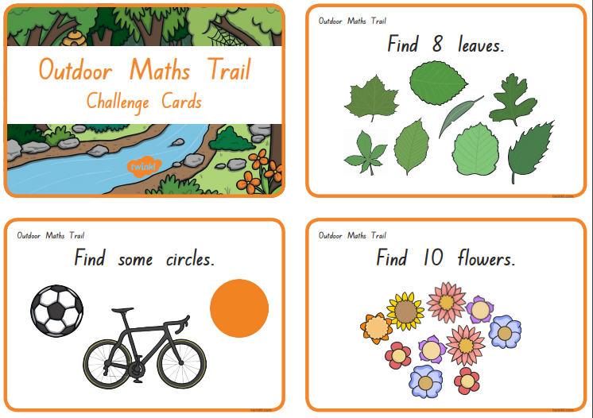
Maths Trail Cards - Take a photo of the things you find and send them to your teacher (Ms Smith: msj.smitholv@gmail.com Ms Behan: msbehan.olv@gmail.com)
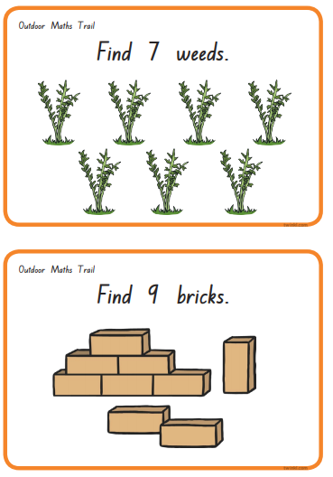

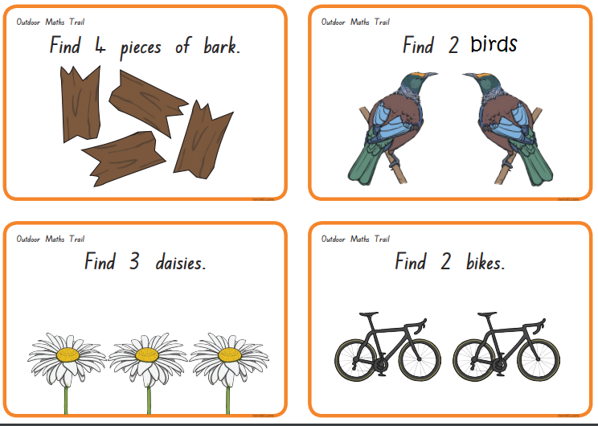

Thursday
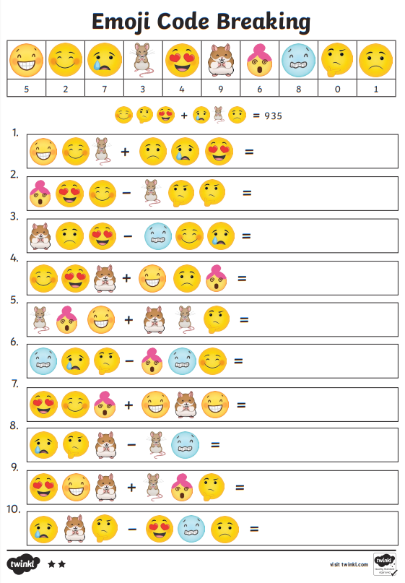
There are 3 Emoji Code Breakers, try as many as you like. Find out what number each emoji stands for and then crack the code!
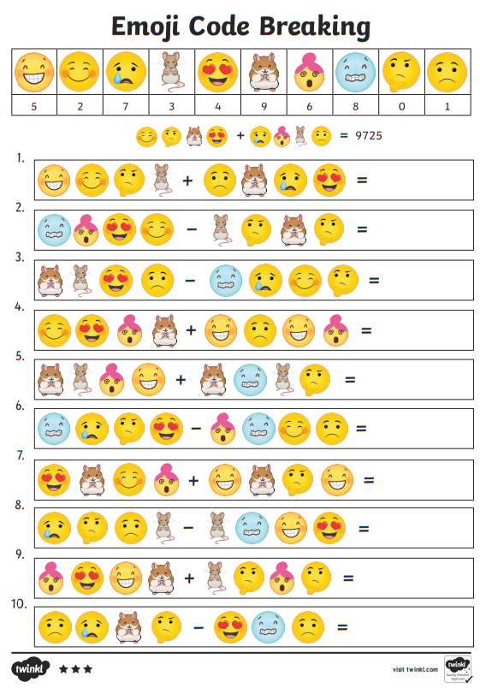
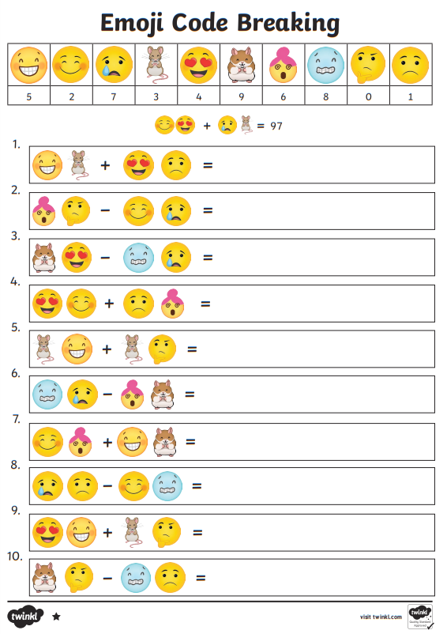
Friday:
Congratulations!
You made it to the Summer holidays!

